**What is a Port Number in Networking?**

A port number is a 16-digit number that acts as a unique identifier for a connection endpoint or a service running on a host. Let’s consider an example for easy understanding.

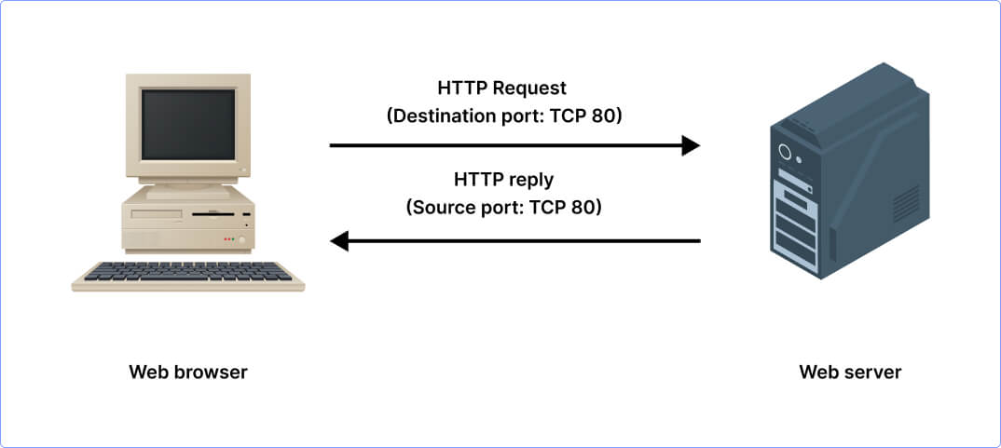

*Suppose you have different services running on your computer like your email, web browser, instant chat app, etc. Now each service you use has its own port number. When you browse a website by typing the web address and hitting enter, your web browser sends a request to get access to the website using port number 80. Likewise, when you open your email client to send an email, it uses port 25 to send your message and as you refresh to check for new emails, the client uses port 110. Further, as you open your instant chat app to talk with a friend in real time, the app communicates using port 6667.*

So, each service you use has its own specific port number. When your device i.e. your computer sends or receives data, it knows which door to use based on the service you’re accessing.

***Insight:****Port Numbers in networking are logical endpoints which is why they are often referred to as Logical Ports as well.*

Which Layer are Ports in the OSI Model?

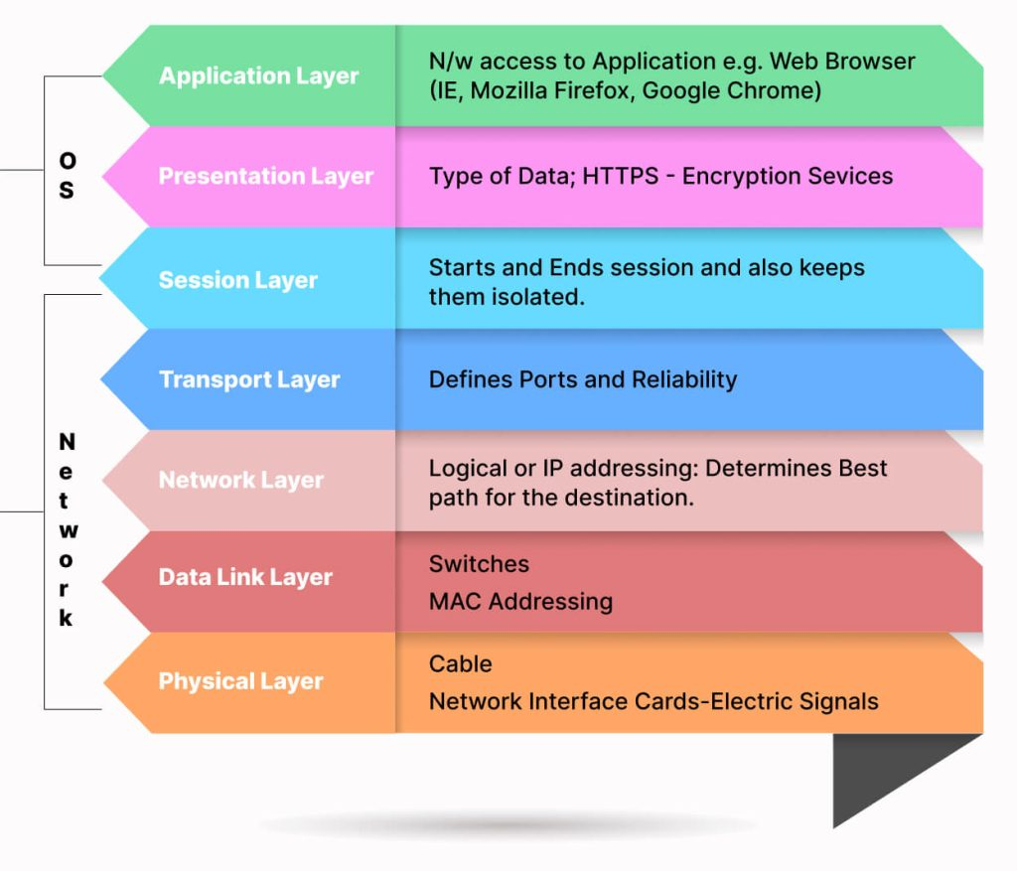

The OSI model is a conceptual model that represents how network communications work. This model has 7 layers shown in the above image. Ports are associated with the Transport Layer i.e. Layer 4 of the OSI model. The Transport Layer primarily makes use of 2 protocols – TCP and UDP. These protocols are needed to specify which port a packet should go to. In the header section of TCP and UDP, the information about port numbers is defined.

Difference Between IP Address and Port Number

In the context of networking, it is important to learn the difference between an IP address and a port number. It will help you understand how data is directed within a network. So let’s take a look:

An IP address identifies a machine in an IP network and is used to identify the destination address of a packet. On the other hand, a port number identifies a certain service or application on a system.

What are the Different Port Numbers?

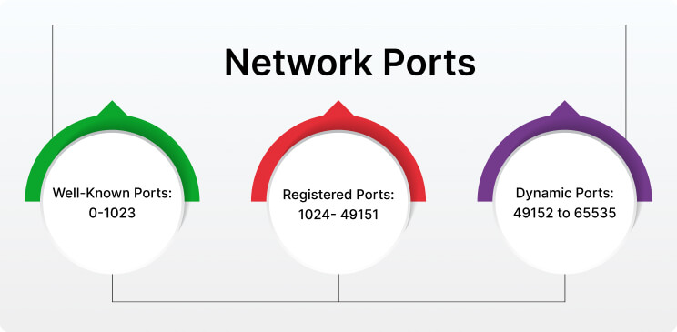

Logical ports are categorized into 3 main types which are:

* Well Known Ports

These port numbers range from 0 to 1023. Well-known port numbers are specifically reserved for standard services. For example, Hyper Text Transfer Protocol i.e. HTTP uses port 80, FTP uses port 21, DNS uses port 53, etc.

* Registered Ports

The range for these ports is from 1024 to 49151. Registered ports are assigned by the Internet Assigned Number Authority (IANA) to specific services and applications that are not very common.

* Dynamic Ports

Dynamic Ports are also called Private Ports or Ephemeral Ports. The range for these ports is 49152 to 65535. These ports are used for short-lived or temporary connections. Also, these ports are not pre-assigned to any specific service.

Now, we have learned about the different types of ports and the port ranges assigned to them. In the next section, let’s catch a glimpse of why these ports hold significant value in networking.

What are some Popular Port Numbers?

There are a total of 65535 port numbers. So their range is from 0 to 65535. The list of port numbers is maintained by IANA and below are some commonly used port numbers along with their service and use. Have a look:

* **21:** It is used by FTP i.e. File Transfer Protocol which transfers files over a network.
* **22:** This port number is used by SSH i.e. Secure Shell which provides a secure remote command-line login.
* **23:** It is used by Telnet for remote terminal access (unencrypted).
* **25:** This port is used by SMTP i.e. Simple Mail Transfer Protocol which is responsible for email routing.
* **53:** It is used by DNS i.e. Domain Name System which resolves domain names to IP addressed.
* **80:** This port number is used by HTTP i.e. Hypertext Transfer Protocol which is used for unencrypted web traffic.
* **110:** It is used by POP3 (Post Office Protocol version 3) which retrieves emails from a server.
* **143:** This port number is used by IMAP i.e. Internet Message Access Protocol which manages and retrieves emails from a mail server.
* **443:** It is used by HTTPS (Hypertext Transfer Protocol Secure) which is used for secure web traffic with encryption.
* **465:** This port number is used by SMTPS (SMTP Secure) which is for secure email sending.
* **123:** It is used by NTP i.e. Network Time Protocol which synchronizes clocks on networked devices.
* **5060:** This port number is used by SIP i.e. Session Initiation Protocol for VoIP communication.
* **16384-32767:** This range of port numbers is used by RTP i.e. Real-time Transport Protocol for audio and video transmission.
* **2049:** It is used by the Network File System for file sharing.
* **3389:** This port is used by RDP i.e. Remote Desktop Protocol to enable users to connect to their desktop computers from another device remotely